**THE MIYAKO BEACH**

**Miyako Island**  is the largest and the most populous island among the [Miyako Islands](https://en.wikipedia.org/wiki/Miyako_Islands" \o "Miyako Islands) of [Okinawa Prefecture](https://en.wikipedia.org/wiki/Okinawa_Prefecture), [Japan](https://en.wikipedia.org/wiki/Japan). Miyako Island is administered as part of the [City of Miyakojima](https://en.wikipedia.org/wiki/Miyakojima,_Okinawa), which includes not only Miyako Island, but also five other populated islands.

`Miyako-jima lies approximately 300 kilometres (186 mi) southwest of [Okinawa Island](https://en.wikipedia.org/wiki/Okinawa_Island). With an area of 158.70 square kilometres (61.27 sq mi), Miyako is the fourth-largest island in Okinawa Prefecture. The island is triangular in shape and is composed of limestone. Miyako-jima is subject to drought and is frequently struck by typhoons.

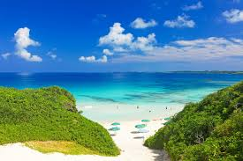

Miyako-jima has a [tropical rainforest climate](https://en.wikipedia.org/wiki/Tropical_rainforest_climate) because all twelve months have a mean temperature of at least 18 °C (64 °F).